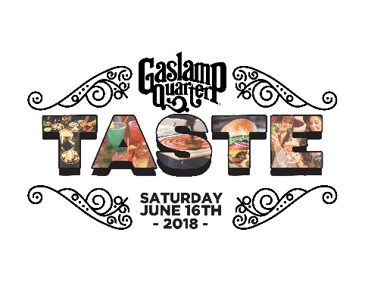
Taste of Gaslamp Restaurant Participation Interest Form
Event Date/Time: Saturday, June 16, 2018- 1:00pm-4:00pm
The Gaslamp Quarter Association wants to showcase the excellent dining options in our vibrant district – and this is your chance to be a part of it and make an impression! The Taste of Gaslamp is San Diego’s original culinary walking tour held for the past 23 years and it will be bigger than ever this year! This will be a great opportunity to expose the delicious cuisines of your establishment to hundreds of guests and entice them to become regular customers.
WHAT YOU DO:
- Provide a “taste” (2 TO 3 OZ SAMPLE) of one or two of your specialties from your menu. Remember, this is your opportunity to entice them to come back for more! We hope to sell 1000 tickets, but will be in touch with you in regard to how many “bites” to prepare closer to the event.
- Set aside a special area for tasters to sit in your restaurant with a small number of tables.
- Provide staff to maintain serving station – they should replenish and serve food
- Provide visible Garbage cans for guests to throw away their trash
- Make sure to display promotions and signs that show other great specials you have going on then and throughout the week.
- Stay open the entire time!

WHAT WE DO:

- Promote the event so that 1000 “foodie fans” buy tickets, enjoy the event, and keep coming back to the Gaslamp Quarter to dine, shop, stay and play
- Posters and printed collateral promoting the event
- 2 ticket types – General Admission and VIP
- Centralized Check In / program provided to all ticket holders
- Goodie Bag for VIP ticket holders
- After party with beer and liquor sponsors
- Great cooperative Advertising Opportunities with Radio and Print Media

please fill out this interest form and scan/ email it to erin@gaslamp.org or sherry@gaslamp.org by March 31st. If you are unsure of your dish, you can submit that later. The GQA staff just wants to start promoting and locking in the locations. The Gaslamp Quarter Association Staff will keep you in the loop in regard to promotions, ticket sales, and other “Taste of Gaslamp” information.

Business Name

Address

Contact | Title GM
Email | Phone
Food Item

